Calibration cheat sheet

Step 1: Set Vcc to exactly = 9V

Step 2: Measure STAIR waveform “treads” in volts. Record in VSTAIR column.

|  |  |  |
| --- | --- | --- |
| Trace | VSTAIR(V) | ib(uA) |
| 9 | ---- | ---- |
| 8 | ---- | ---- |
| 7 | ---- | ---- |
| 6 | 7.36 | 28 |
| 5 | 6.16 | 23 |
| 4 | 4.96 | 18 |
| 3 | 3.76 | 13 |
| 2 | 2.53 | 7.8 |
| 1 | 1.31 | 2.6 |
| 0 | ---- | ---- |

Step 3: Convert VSTAIR into base current using the following:

$$i_{b}=\frac{V_{STAIR}- 0.7}{100kΩ}$$

You should only do steps 1-3 once. Cut-and-paste IB into all tables.

Step 4: Probe CH_X/CH_Y with oscope channels 1/2. Put scope in X/Y

Step 5: Measure curves at VCE = 1V. Record in VIC (mV) column

Step 6: Convert VIC into iC using the following:

$$i_{c}=\frac{V_{ic}}{100Ω}$$

Step 6: Form ratio of collector to base current.

BJT Performance Card Name: ________________

Device ID: 2N3904 TO-92

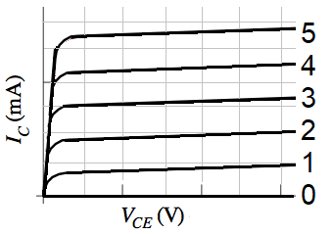

|  |  |
| --- | --- |
| Trace | ib (uA) |
| 6 |  |
| 5 |  |
| 4 |  |
| 3 |  |
| 2 |  |
| 1 |  |
| 0 | --- |

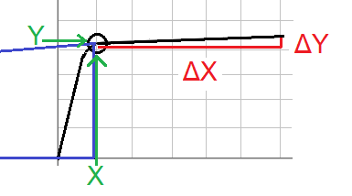Gain Calculation

|  |  |  |  |
| --- | --- | --- | --- |
| Trace | Vic(mV) | ic(mA) | ic/ib |
| 6 |  |  |  |
| 5 |  |  |  |
| 4 |  |  |  |
| 3 |  |  |  |
| 2 |  |  |  |
| 1 |  |  |  |
| 0 | 0 | 0mA | ------ |

Early Voltage

|  |  |  |  |  |  |
| --- | --- | --- | --- | --- | --- |
| Trace | X | Y | ΔY | ΔX | X- Y (ΔX/ ΔY) |
| 6 |  |  |  |  |  |
| 5 |  |  |  |  |  |
| 4 |  |  |  |  |  |

BJT Performance Card Name: ________________

Device ID: 2N2222 TO-18



|  |  |
| --- | --- |
| Trace | ib (uA) |
| 6 |  |
| 5 |  |
| 4 |  |
| 3 |  |
| 2 |  |
| 1 |  |
| 0 | --- |

Gain Calculation

|  |  |  |  |
| --- | --- | --- | --- |
| Trace | Vic(mV) | ic(mA) | ic/ib |
| 6 |  |  |  |
| 5 |  |  |  |
| 4 |  |  |  |
| 3 |  |  |  |
| 2 |  |  |  |
| 1 |  |  |  |
| 0 | 0 | 0mA | ------- |

Early Voltage

|  |  |  |  |  |  |
| --- | --- | --- | --- | --- | --- |
| Trace | X | Y | ΔY | ΔX | X- Y (ΔX/ ΔY) |
| 6 |  |  |  |  |  |
| 5 |  |  |  |  |  |
| 4 |  |  |  |  |  |

BJT Performance Card Name: ________________

Device ID: BD139 TO-126



|  |  |
| --- | --- |
| Trace | ib (uA) |
| 6 |  |
| 5 |  |
| 4 |  |
| 3 |  |
| 2 |  |
| 1 |  |
| 0 | --- |

Gain Calculation

|  |  |  |  |
| --- | --- | --- | --- |
| Trace | Vic(mV) | ic(mA) | ic/ib |
| 6 |  |  |  |
| 5 |  |  |  |
| 4 |  |  |  |
| 3 |  |  |  |
| 2 |  |  |  |
| 1 |  |  |  |
| 0 | 0 | 0mA | ------ |

Early Voltage

|  |  |  |  |  |  |
| --- | --- | --- | --- | --- | --- |
| Trace | X | Y | ΔY | ΔX | X- Y (ΔX/ ΔY) |
| 6 |  |  |  |  |  |
| 5 |  |  |  |  |  |
| 4 |  |  |  |  |  |